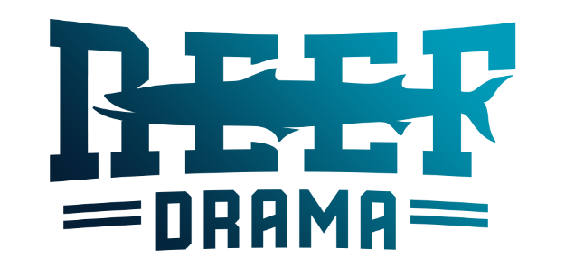

Name of Student: ___________________________________
Grade: _____________
Apparel Pre-Order Form 2022-2023
**Please (X) the size you would like.
Item | STYLE | Description | YL | XS | S | M | L | XL | 2XL | 3XL
Reef Drama Sweatshirt  Pull Over Hoodie $40 | 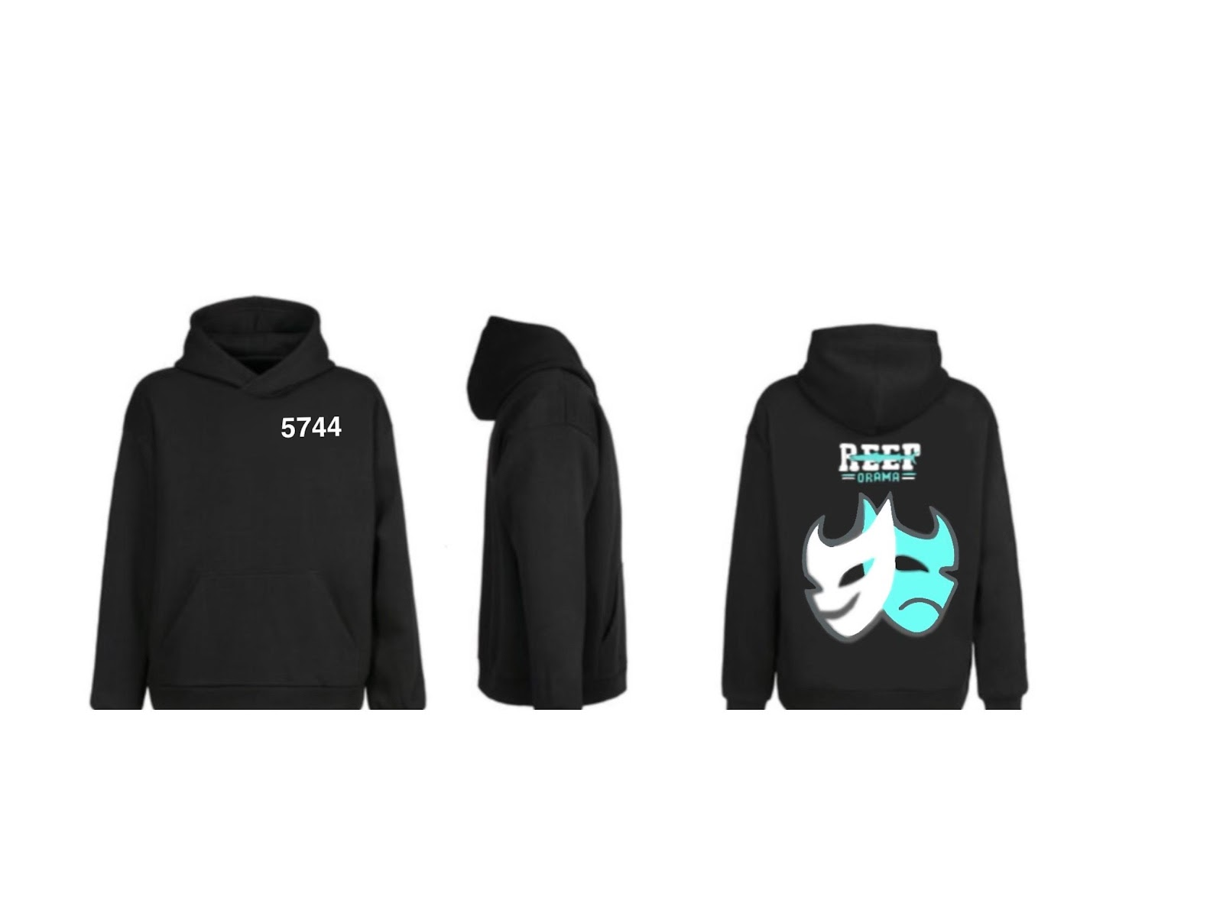 | Reef Drama Logo Black with 5744 on front top left
Reef Drama SS Shirt  Regular Crew Neck $20  Women V- Neck $20  Please indicate color choice: Black  White/Grey/Black | 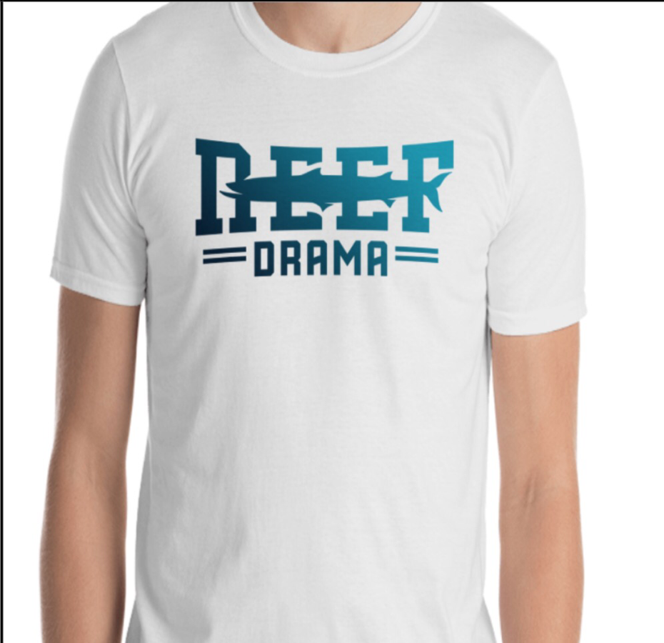 | Reef Drama Front  Choose Color.
T3 [Tech Club] T Shirt  $20  Black Only | 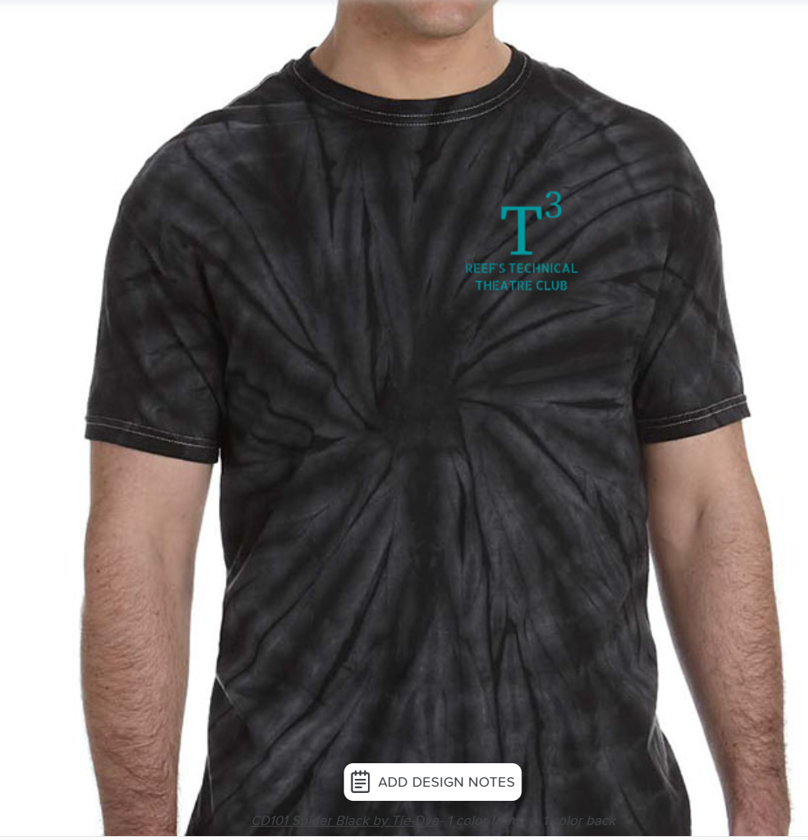 | Plain White ( You are to tie dye yourself)
Sweatpants  $40.00 | 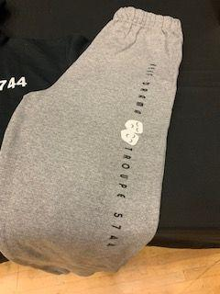 | Gray
Black Long Sleeve Zip Up JACKET  $60  ___________________  Front Says Troupe 5744 | 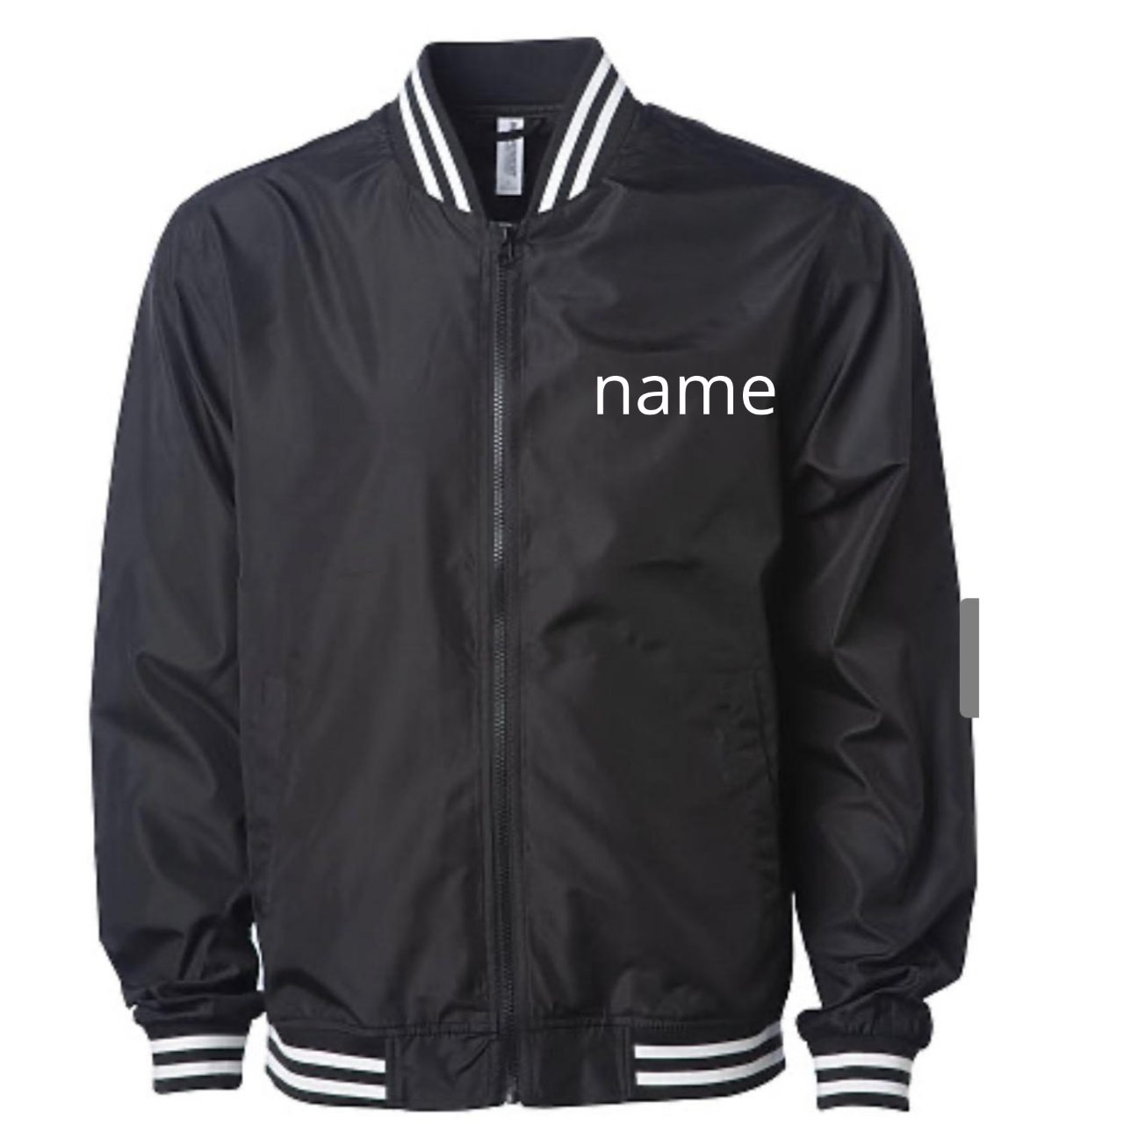 | 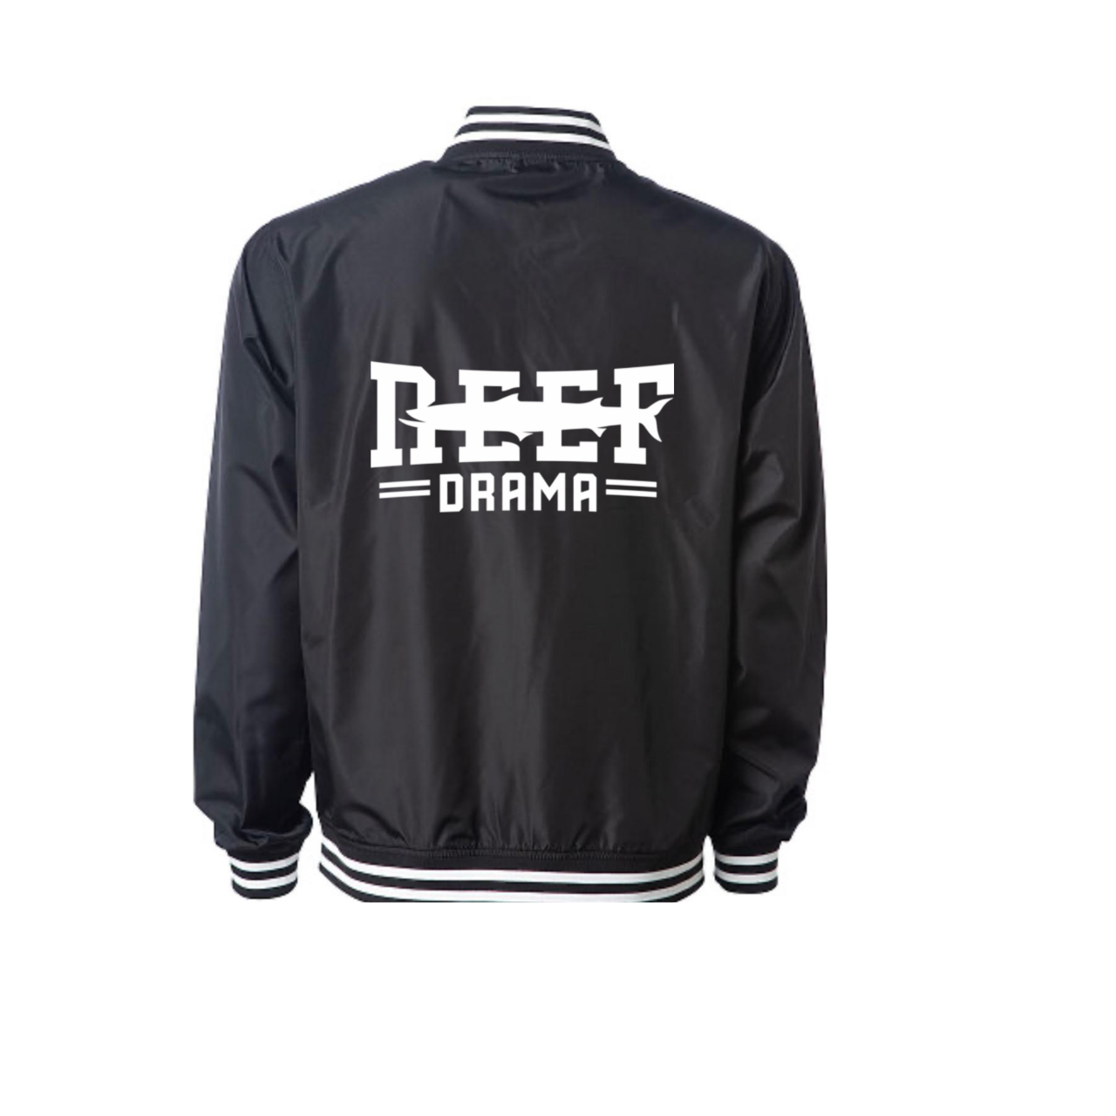
Happiest Stage Club T-Shirt - Mint  $20.00  Custom Front: Cast  Member ____________ | 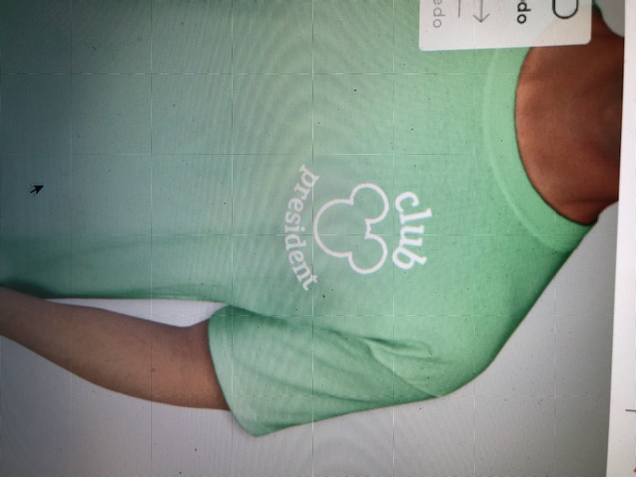

Reef Drama Hoodie Sweatshirt $40.00  Please indicate color choice: White/Grey/Black  Black | 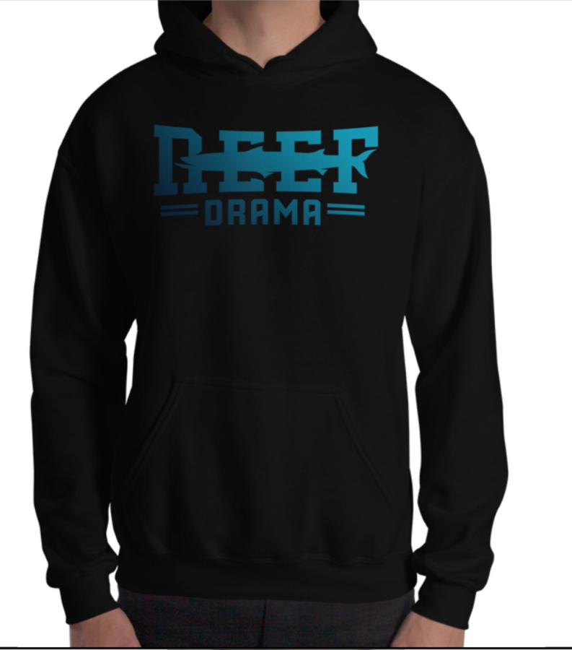 | Plain Back

Reef Drama Mama or Dad Shirt  Crew or V-Neck Fitted  $20.00  Specify: Mama or Dad  __________________ |  | Personalization included

TOTAL DUE: $___________________ (please indicate payment method)

We accept: Checks, PayPal & Venmo & Cashapp
Please make checks payable to Caught in the Act, Inc
ADD note with Student Name/Grade and what is being paid: Apparel, Membership, Donation, etc.
Please Choose: Friends & Family not Goods and Services to avoid fees

VENNMO: @dramatroupe5744 PAYPAL: dramatroupe5744@gmail.com CASHAPP: $reefdrama

